TSLA x ACC-TTT: Evolving LDL-C Management

主辦單位：中華民國血脂及動脈硬化學會
協辦單位：台灣安進藥品有限公司
時間：2021年10月30日 (六)
地點: 暫定台北現場 + 線上 (備選方案: 純線上)
本活動與中華民國血脂及動脈硬化學會合辦，心臟學分、內科學分、內分泌學分、藥師學分，家庭醫學醫學會，申請中。

Time | Topic | Speaker | Moderator
13:30-14:00 | Registration
14:00-14:10 | Opening Remarks |  | 黃柏勳 醫師  台北榮總
14:10-15:00 | Early LDL-C management in post-ACS: insights from ESC 2021 and case discussion | 李俊偉醫師 台北馬偕
15:00-15:50 | Who demonstrates better outcomes in non-statin lipid management? and case discussion | 邱淳志醫師  雙和醫院
15:50-16:00 | Break
16:00-16:50 | Intensive lipid lowering in hypercholesterolemia: what we have learned from patients | 劉維新醫師  花蓮慈濟 | 劉秉彥 教授
16:50-17:00 | Panel discussion

日期 | 2021/10/30 | 時間 | 14:10-10:50
講者 | 李俊偉醫師  - 馬偕紀念醫院心臟內科主治醫師  - 馬偕紀念醫院病房主任  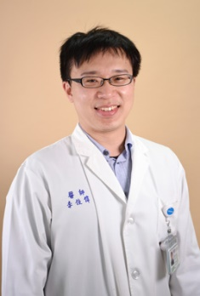
主題 | Early LDL-C management in post-ACS: insights from ESC 2021
摘要
RCTs have unequivocally established that lowering levels of LDL-C reduces CV event rates in secondary prevention setting. Previous intracoronary imaging studies demonstrated that intensive lipid lowering therapy slowed disease progression and promoted atherosclerotic plaque regression. However, not only the plaque burden, but also the plaque composition plays a role in the improved CV outcomes. Increasing evidence has suggested that both statins and non-statin-based lipid lowering therapies can modulate factors within plaque that confers a vulnerable state. As such, stabilizing the vulnerable plaque may become a new target for secondary prevention.

The first half of Dr. Lee’s session will focus on the latest clinical benefits of intensified lipid-lowering in post-ACS care, along with a summary of plaque modulation trials by intensified lipid-lowering. Dr. Lee will then introduce the results of the latest ESC data on vulnerable plaque stabilization in ACS after treatment with PCSK9 inhibitor, which provide insights regarding the benefits of early and aggressive lipid lowering in secondary prevention settings.

日期 | 2021/10/30 | 時間 | 14:50-15:30
講者 | 邱淳志醫師  - 雙和醫院心臟內科專任主治醫師  - 國立陽明大學醫學系講師  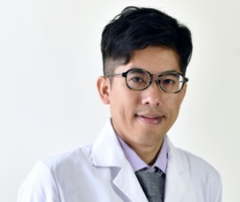
主題 | Who demonstrates better outcomes in non-statin lipid management?
摘要
Lowering LDL-C has been integral part of the treatment of patients with ASCVD, with statins being the mainstay of therapy. Over the last 4 years, the FOURIER and ODESSY Outcomes Trials have demonstrated favorable efficacy and safety of PCSK9 inhibitors when added to stains. Despite the exciting experience from these successful clinical trials, the cost of these novel agents remains an issue. With a growing desire for personalized and cost-efficient medicine, it is reasonable to seek to identify subgroups of patients who demonstrate better outcomes from PCSK9 inhibition.

In this session, Dr. Chiu will present key subgroups analyses in various PCSK9 inhibitor trials that helped to identify several high-risk subgroups, such of MI & stroke. The impact of timing of PCSK9 inhibitor initiation on CV outcomes will also be reviewed. Finally, Dr. Chiu will share his clinical experience with PCSK9 inhibitor in management of high-risk subgroups that are aligned with the latest lipid management guidelines.

日期 | 2021/10/30 | 時間 | 15:45-16:25
講者 | 劉維新醫師  - 佛教慈濟醫療財團法人花蓮慈濟醫院心臟內科心功能檢查室主任  - 佛教慈濟醫療財團法人花蓮慈濟醫院心臟內科主治醫師  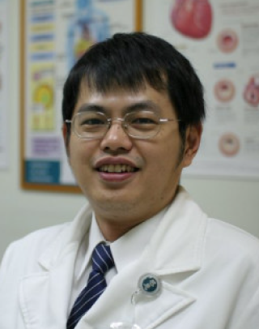
主題 | Intensive lipid lowering in hypercholesterolemia: what we have learned from patients
摘要
The benefit of intensive lipid lowering therapies in high-risk patients with hypercholesterolemia is evident. Despite generally good tolerability, these agents may cause allergy or intolerance in some occasions which limit their optimized use. Besides, sometimes these safety signals may be easily missed unless careful inquiry and examination are performed.

In this educational session, Dr. Liu will present limitations of available lipid lowering medication options based on clinical evidence, with safety and long-term efficacy highlighted. Dr. Liu will also share stories of patients with statin intolerance or with limited statin response, and how switching to alternative lipid-lowering therapy helped to achieve their optimized LDC-C goals without compromising on safety.

